Prompt Portfolio & AI-Assisted Research
Part B — Integrated AI Business Case Study, Prompt Research & Presentation
Topic: Prompt Engineering Foundations — 25 Prompts Portfolio
Course: Introduction to Artificial Intelligence and Machine Learning
Student Name: [Harkirat kaur ]
Roll Number: [2520992608]
Departments: [BBA Fintech & AI ]

Introduction
This portfolio contains 25 prompts written using the Role + Context + Task + Format (R-C-T-F) structure, Zero-Shot Prompting, and Few-Shot Prompting taught in the Prompt Engineering Foundations module. Each prompt includes the business problem it addresses, the prompt itself, a genuine AI-generated response, and a placeholder for your own screenshot of running that prompt.
Note: The AI Output shown for each prompt below is a real, generated response — use it as your reference answer, but re-run each prompt yourself in your chosen AI tool (Claude, ChatGPT, Gemini, etc.) and paste your own screenshot in the placeholder box, since the assessment requires you to demonstrate your own use of AI, not a pre-written answer.

1. Marketing Prompts (1–5)

1. Social Media Campaign for Eco-Friendly Water Bottle (R-C-T-F)
Business Problem: Launch awareness for a new reusable water bottle targeted at college students.
Act as a social media manager. Our company is launching a reusable, eco-friendly water bottle for college students in India. Our target audience is students aged 18-24 who care about sustainability and price. Create 5 social media campaign ideas. Present the output as a table with Idea, Platform and Goal.
AI Output:
Idea | Platform | Goal
"Campus Refill Challenge" — students post refill photos instead of buying disposables | Instagram Reels | Drive awareness & UGC
Partner with campus sustainability clubs for discount codes | Instagram/WhatsApp | First sales via trusted voices
"30-Day Plastic-Free Challenge" hashtag with student influencers | Instagram/TikTok | Build community engagement
Referral discount — bring a friend, both get 10% off | WhatsApp/Stories | Word-of-mouth growth
Reel comparing cost of bottled water vs. reusable bottle per semester | Reels/Shorts | Highlight savings, drive conversion
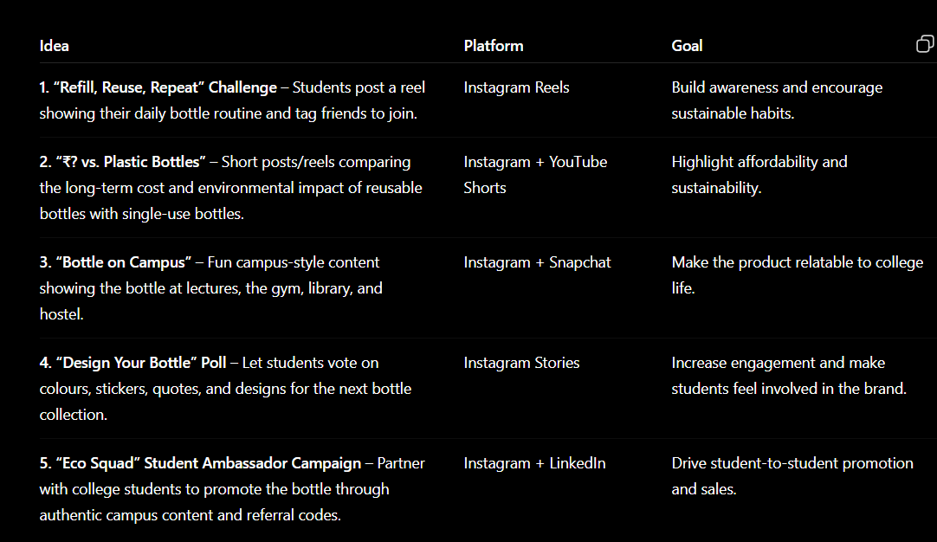

2. Taglines for Eco-Friendly Water Bottle (Zero-Shot)
Business Problem: Need short, memorable brand taglines.
Create three taglines for an eco-friendly water bottle targeted at college students.
AI Output:
- "Refill. Reuse. Repeat — Your Campus, Your Planet."
- "One Bottle. Zero Waste. Endless Refills."
- "Hydrate Smart, Live Green."
[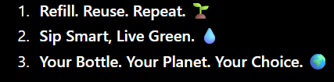

3. Low-Cost Marketing Ideas for a Fitness App (Zero-Shot)
Business Problem: Need a low-budget marketing plan for a new fitness app.
Suggest 5 low-cost marketing ideas for a new affordable fitness app targeting Indian college students. Present the answer in a table with Idea, Channel and Expected Benefit.
AI Output:
Idea | Channel | Expected Benefit
Campus ambassador program (referral = free premium) | Word of mouth/Instagram | Low-cost user acquisition
Free 7-day trial shared in college WhatsApp groups | WhatsApp | Quick trial signups
Co-promotion with college gyms/sports clubs | Offline/Instagram | Credibility + reach
User "transformation" reel contest | Instagram Reels | Organic virality
Email/SMS reminders with free workout tips | Email/SMS | Retention at near-zero cost
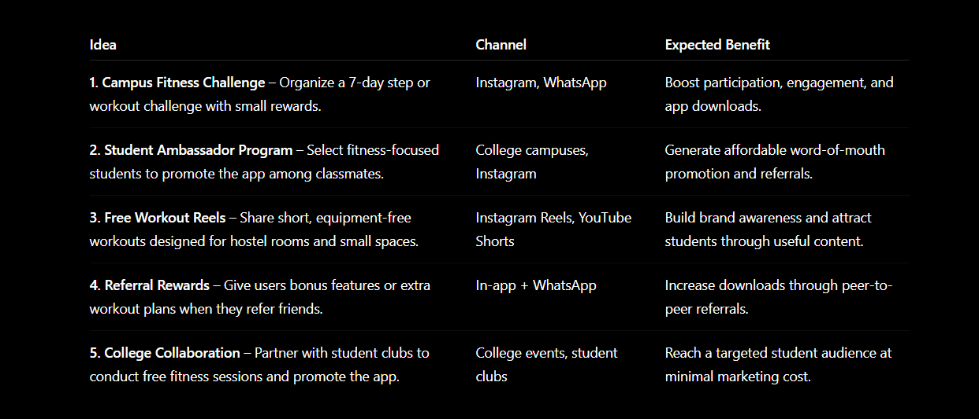

4. 7-Day Instagram Campaign for Fitness App (R-C-T-F)
Business Problem: Need a structured week-long launch campaign.
Act as a digital marketing manager. Create a 7-day Instagram campaign for an affordable fitness app targeting Indian college students aged 18-24. Present the answer in a table with Day, Content Idea, Caption Theme and CTA.
AI Output:
Day | Content Idea | Caption Theme | CTA
1 | Introduce app & problem it solves | Fitness made affordable | Download now, first week free
2 | Student testimonial reel | Real students, real results | Tag a friend to start together
3 | 30-sec home workout demo | No gym, no excuse | Try this workout in the app
4 | Trainer introduction | Meet your trainers | Book a free session
5 | Myth vs. fact fitness post | Fitness facts vs. myths | Swipe to learn more
6 | Discount countdown | 48 hours left | Upgrade before it's gone
7 | Weekly recap + shoutouts | This week in fitness | Join the community
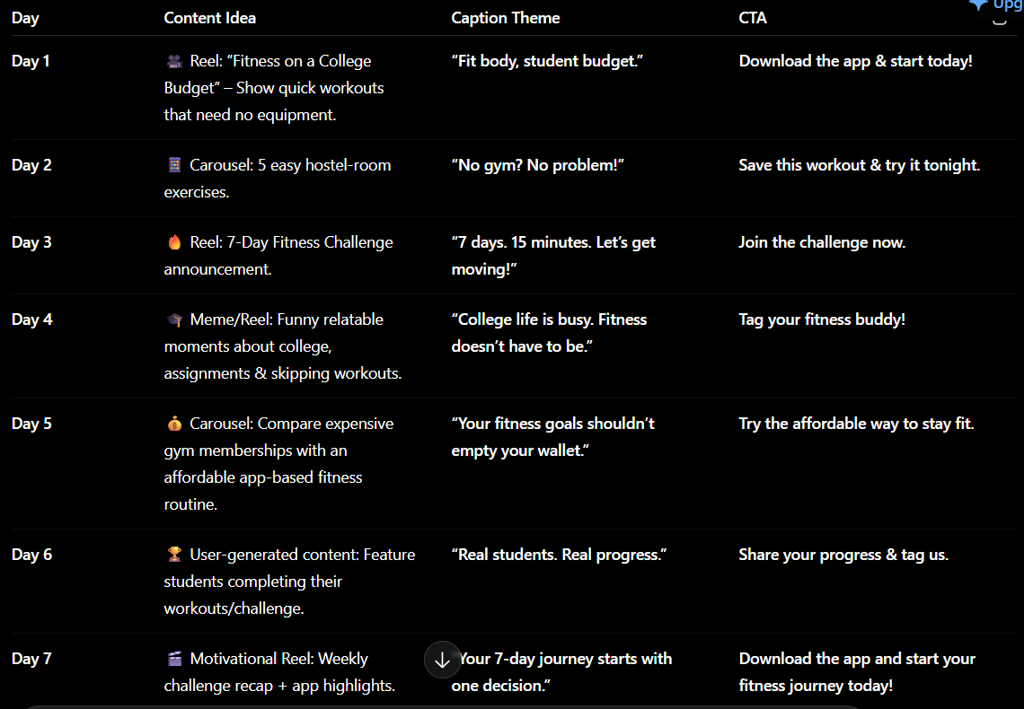

5. Improving a Vague Marketing Prompt (Prompt Improvement)
Business Problem: A first-draft prompt was too vague to be useful.
Poor Prompt: "Create a campaign."
Improved Prompt: "Act as a marketing manager. A new café has opened near a university. Its target customers are students aged 18-24 and the marketing budget is limited. Suggest five low-cost promotional ideas to increase weekday visits. Present the answer in a table with Marketing Idea, Channel and Expected Benefit."
AI Output:
Marketing Idea | Channel | Expected Benefit
Student ID discount on weekdays | In-store signage | More weekday footfall
Free WiFi + study-hour combo offer | Instagram/Word of mouth | Longer visits, repeat customers
Collaborate with a student club for a meet-up event | Campus notice boards/Instagram | Bulk footfall in one visit
"Bring a friend" happy-hour discount | Instagram Stories | Word-of-mouth growth
Loyalty punch-card for 5th coffee free | In-store | Repeat visits
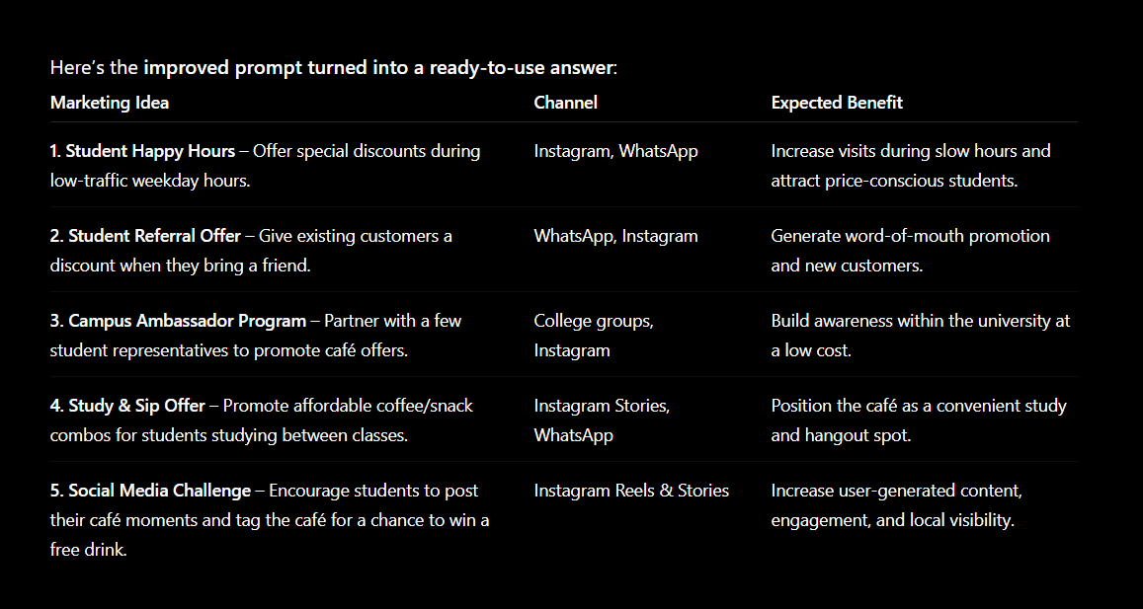

2. HR Prompts (6–10)

6. Job Description for Marketing Intern (Zero-Shot)
Business Problem: Need a job description for a fashion e-commerce internship.
Act as an HR executive. Create a short job description for a Marketing Intern at a fashion e-commerce company. Include responsibilities, required skills and qualifications. Use professional but student-friendly language.
AI Output:
Job Title: Marketing Intern — Fashion E-commerce
Responsibilities: Assist with the social media content calendar; support influencer outreach; analyze campaign performance metrics; help coordinate product photoshoots.
Required Skills: Basic knowledge of Instagram/Meta Ads, strong writing skills, familiarity with Canva or similar tools, analytical mindset.
Qualifications: Pursuing or completed a BBA or related degree; prior internship experience is a plus but not mandatory.

7. Interview Questions for Marketing Intern (Zero-Shot)
Business Problem: Need structured interview questions for hiring.
Write five interview questions for a Marketing Intern.
AI Output:
- "Describe a marketing campaign you found effective. Why did it work?"
- "How would you plan a low-budget campaign for a college audience?"
- "Which social media metrics matter most for a fashion brand, and why?"
- "Tell us about a time you had to learn a new tool quickly."
- "How do you stay updated on marketing trends?"
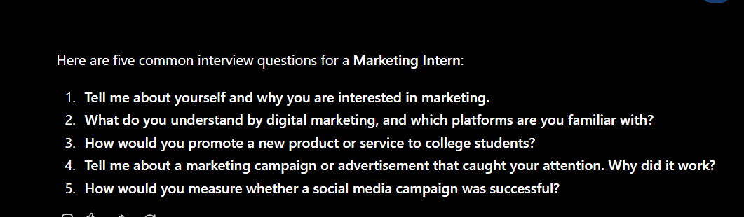

8. Sales Intern Interview Questions with Skill Mapping (R-C-T-F)
Business Problem: Hiring a Sales Intern and need questions that map to specific skills.
Act as an HR manager. We are hiring a Sales Intern for a B2C startup. Create 5 interview questions, the skill each question tests, and what a good answer should demonstrate. Present the result in a table.
AI Output:
Question | Skill Tested | Good Answer Demonstrates
"Tell me about a time you convinced someone to change their mind." | Persuasion | Structured reasoning, empathy, clear outcome
"How would you handle a customer who says your product is too expensive?" | Objection handling | Value-based response, not just discounting
"Describe your approach to following up with an unresponsive lead." | Persistence | Systematic follow-up, not pushiness
"What would you do if you missed your weekly sales target?" | Resilience | Ownership, specific corrective action
"How do you prioritize 20 leads in one day?" | Time management | Clear prioritization logic

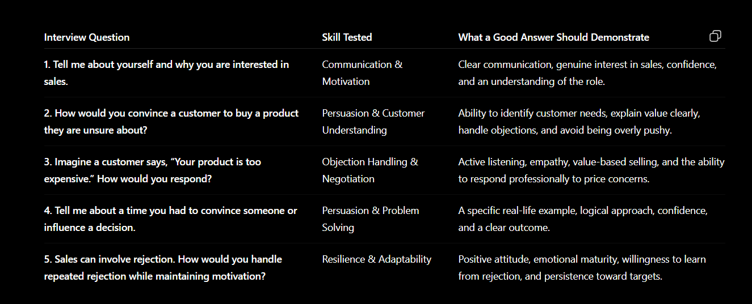

9. Improving a Vague Job-Description Prompt (Prompt Improvement)
Business Problem: A first-draft HR prompt gave a generic, unusable job description.
Poor Prompt: "Write a job description."
Improved Prompt: "Act as an HR executive. Create a job description for a Digital Marketing Intern at a D2C skincare startup. Include responsibilities, required skills, and qualifications. Keep it under 150 words, in a professional but student-friendly tone."
AI Output:
Job Title: Digital Marketing Intern — D2C Skincare Startup. Responsibilities: manage the content calendar, assist with paid ad creatives, track basic campaign metrics. Skills: familiarity with Instagram/Meta Ads Manager, good writing, basic Excel. Qualifications: pursuing a BBA/marketing degree; no prior experience required.
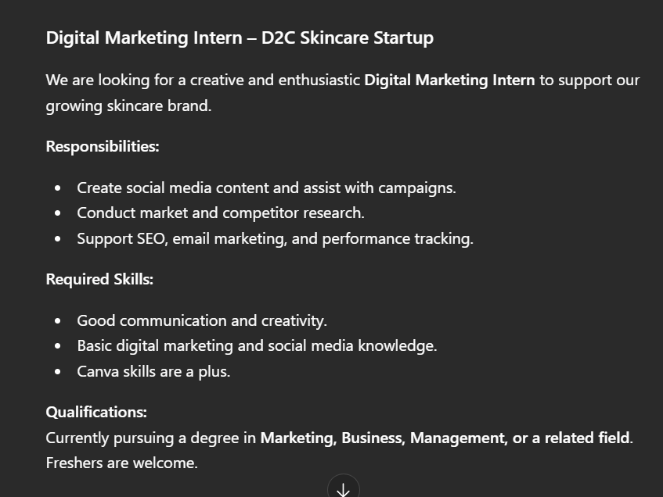

10. Improving a Vague Customer-Analysis Prompt (Prompt Improvement)
Business Problem: A first-draft prompt produced an unfocused customer analysis.
Poor Prompt: "Analyze customers."
Improved Prompt: "Act as a business analyst. We run a D2C skincare brand. Analyze our customers based on age group, purchase frequency, and product preference. Suggest 3 customer segments and one marketing action for each. Present the answer in a table with Segment, Key Trait and Recommended Action."
AI Output:
Segment | Key Trait | Recommended Action
Gen-Z first-time buyers (18-22) | Price-sensitive, social-media driven | Trial-size bundles + influencer collabs
Repeat buyers (23-30) | Higher basket value, brand-loyal | Loyalty/subscription discounts
Occasional gift buyers | Buy around festivals/occasions | Festive gift-set promotions
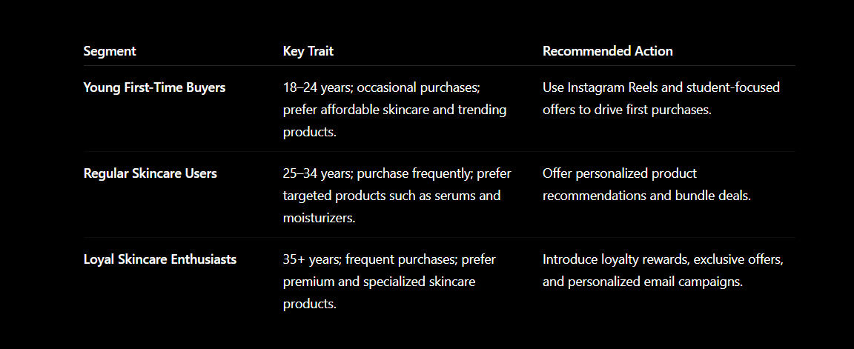

3. Finance Prompts (11–15)

11. Explaining Profit Margin Simply (Zero-Shot)
Business Problem: Need a simple explanation of profit margin for a non-finance audience.
Explain profit margin to a BBA student using a simple business example.
AI Output:
Profit margin shows how much of every rupee in sales a business actually keeps as profit. Example: a café sells a coffee for ₹100. If it costs ₹40 to make (ingredients, staff time, etc.), the profit is ₹60, so the profit margin is 60% (60/100 x 100).
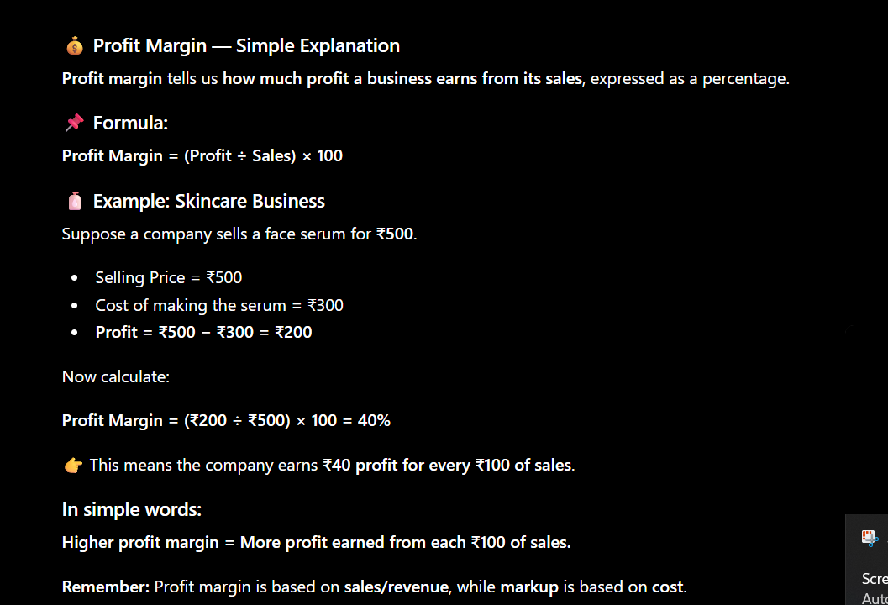

12. Revenue, Profit and Profit Margin Table (R-C-T-F)
Business Problem: Need a simple table explaining three related finance terms.
Act as a finance trainer for BBA students. Explain Revenue, Profit and Profit Margin using one simple café example. Avoid technical language. Present the answer in a table with Term, Meaning and Example.
AI Output:
Term | Meaning | Example
Revenue | Total money earned from sales, before expenses | Café sells 100 coffees at ₹100 = ₹10,000 revenue
Profit | What's left after subtracting all costs from revenue | If costs are ₹6,000, profit = ₹4,000
Profit Margin | Profit as a percentage of revenue | ₹4,000 / ₹10,000 = 40% profit margin
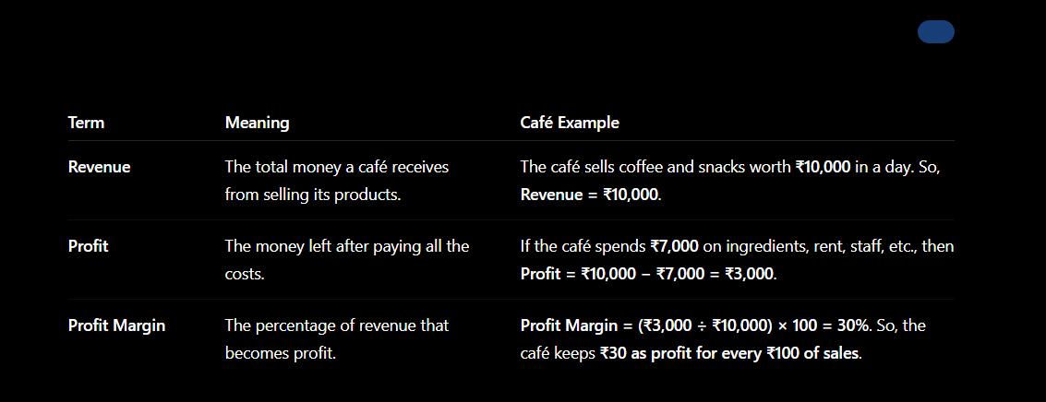

13. Explaining Break-Even Point (Zero-Shot)
Business Problem: Need a simple explanation of break-even for a food stall example.
Act as a finance trainer. Explain the break-even point to a BBA student using a simple example of a food stall. Avoid technical jargon.
AI Output:
Break-even is the point where a business earns exactly enough to cover its costs — no profit, no loss. Example: a food stall's fixed cost (rent + staff) is ₹5,000/day, and each plate sells for ₹50 with a ₹30 cost, so profit per plate is ₹20. Break-even = ₹5,000 / ₹20 = 250 plates/day. Selling fewer than 250 plates means a loss; more means profit.
Act as a finance trainer. Explain the break-even point to a BBA student using a simple example of a food stall. Avoid technical jargon.
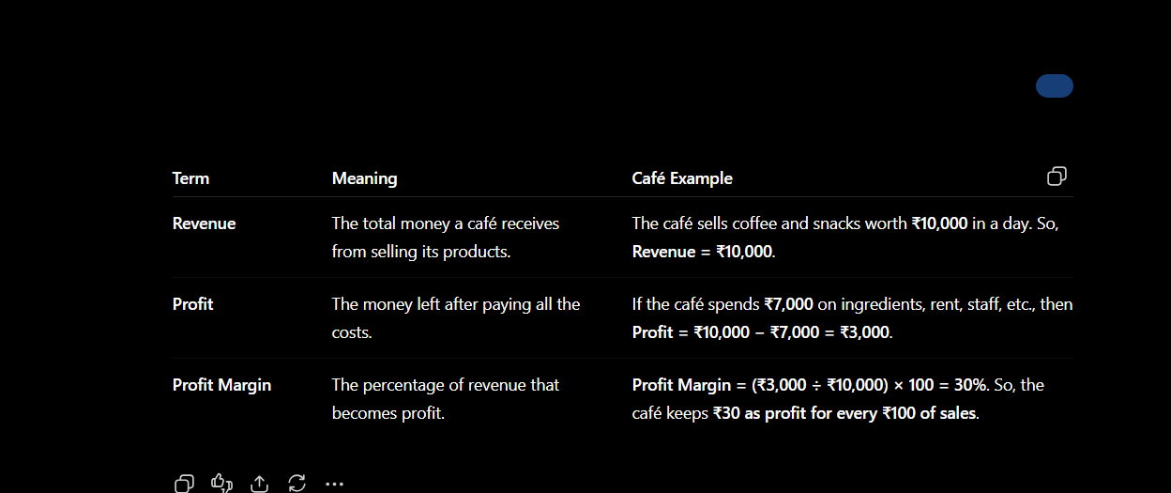

14. Cash Flow vs. Profit (Zero-Shot)
Business Problem: Need a simple explanation distinguishing cash flow from profit.
Explain the difference between cash flow and profit to a BBA student using a simple retail example.
AI Output:
Profit is what's left after subtracting expenses from revenue on paper. Cash flow is the actual movement of money in and out of the business. Example: a shop sells ₹50,000 worth of goods on credit in a month — it shows profit, but if customers haven't paid yet, the shop has no actual cash in hand to pay its own bills. That's positive profit but negative case flow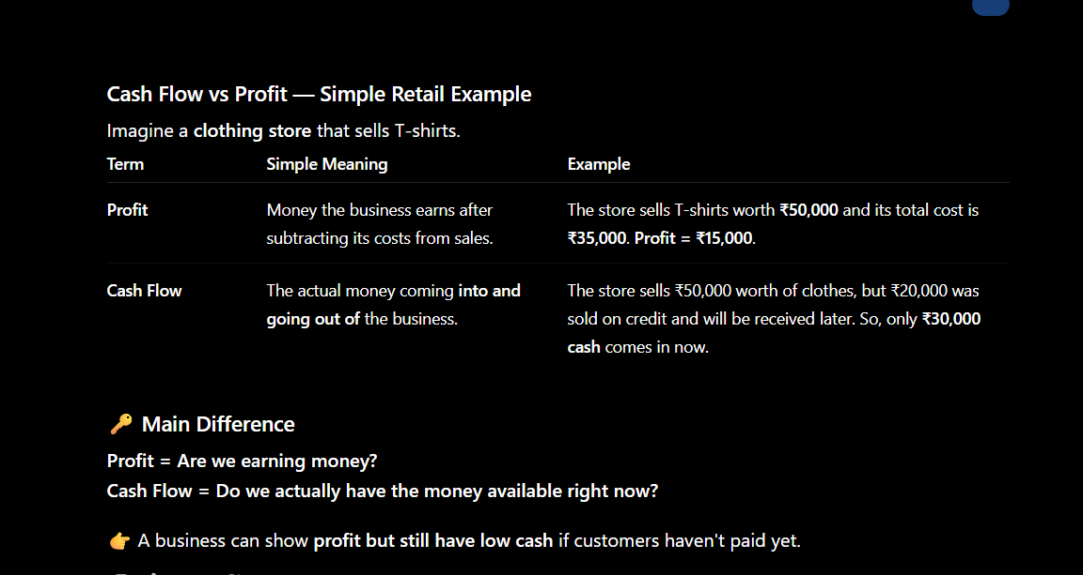

15. Financial Risk Analysis for Your Case-Study Company (R-C-T-F)
Business Problem: Need to identify financial risks for the company chosen in Part A.
Act as a financial analyst. For [insert your case-study company name], identify 3 major financial risks the company might face (e.g., currency risk, credit risk, market risk) and one mitigation strategy for each. Present the answer in a table with Risk, Description and Mitigation.
AI Output:
[This prompt is company-specific — run it with the actual company you selected for Part A of your case study and paste the real output and screenshot here.]
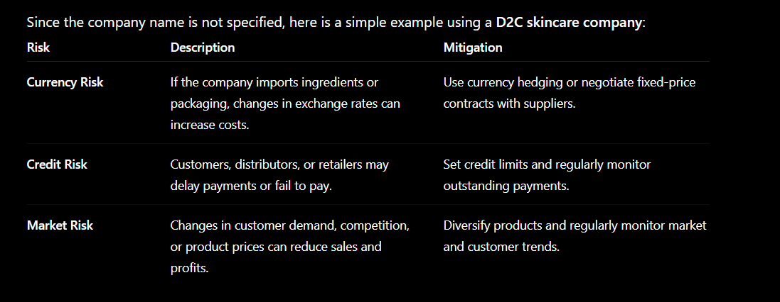

4. Operations Prompts (16–20)

16. Reducing Restaurant Waiting Time (Zero-Shot)
Business Problem: A restaurant wants to reduce customer waiting time.
Suggest four ways a restaurant can reduce customer waiting time.
AI Output:
- Use a digital token/queue system so customers see real-time wait estimates.
- Pre-take simple orders (drinks/starters) while customers wait to be seated.
- Prep high-demand items in advance during known peak hours.
- Offer table-side QR ordering to skip waiting for a waiter.
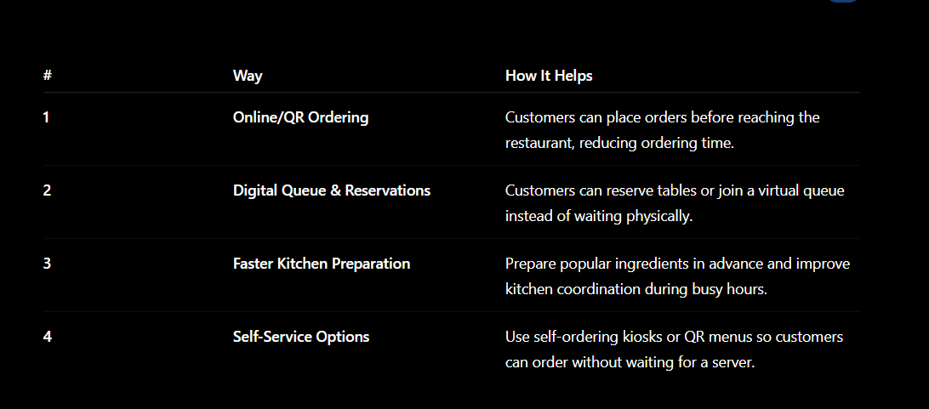

17. Late Evening Delivery Causes and Solutions (R-C-T-F)
Business Problem: An online retailer is receiving complaints about late deliveries.
Act as a business analyst. An online retailer receives complaints about late deliveries. Identify possible causes, suggest five solutions, and explain the expected business benefit of each solution. Present the answer in a table.
AI Output:
Possible Cause | Suggested Solution | Expected Business Benefit
Limited delivery staff during peak evening hours | Add flexible part-time riders for peak slots | Faster deliveries, fewer complaints
Inefficient route planning | Use route-optimization software | Lower delivery time & fuel cost
Kitchen/warehouse delays during high order volume | Batch-prepare popular items in advance | Reduced prep-to-dispatch time
Poor order-to-rider assignment | Automate rider assignment by proximity | Reduced pickup delay
No visibility for customers | Real-time order tracking | Better experience, fewer complaint calls
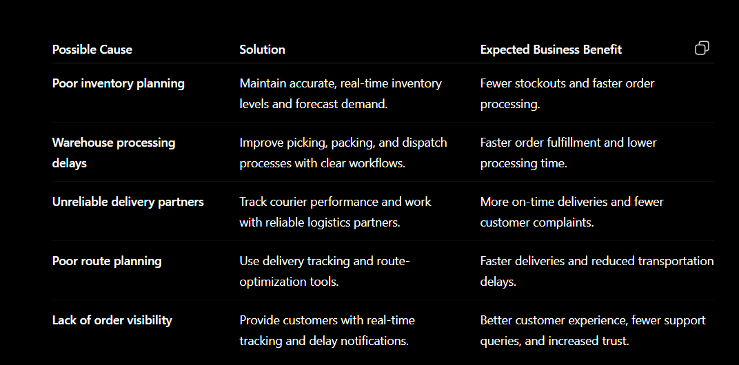

18. Improving a Vague Operations Prompt (Prompt Improvement)
Business Problem: A first-draft operations prompt was too vague to act on.
Poor Prompt: "Solve delivery problem."
Improved Prompt: "A food-delivery company is receiving complaints about late evening deliveries. Suggest 5 possible operational improvements. Present each suggestion with its expected business benefit."
AI Output:
(See the full table in Prompt 17 above — the improved prompt produced the same specific, benefit-linked format, because it named the exact problem, asked for a fixed number of solutions, and specified the output should include the business benefit.)
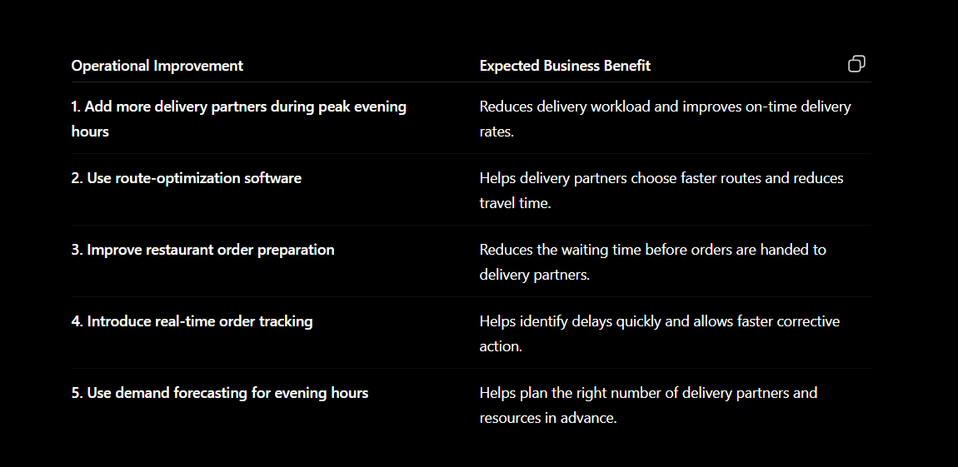

19. Inventory Optimization Ideas (Zero-Shot)
Business Problem: An online retailer frequently runs out of best-selling products.
Suggest 4 inventory optimization ideas for an online retailer that frequently runs out of best-selling products.
AI Output:
- Set automatic reorder alerts when stock falls below a defined threshold for top sellers.
- Use past sales data to forecast demand before major sale events (e.g., festive season).
- Maintain a small safety-stock buffer for high-velocity SKUs.
- Negotiate faster replenishment cycles with suppliers for the top 20% of products that drive most sales.
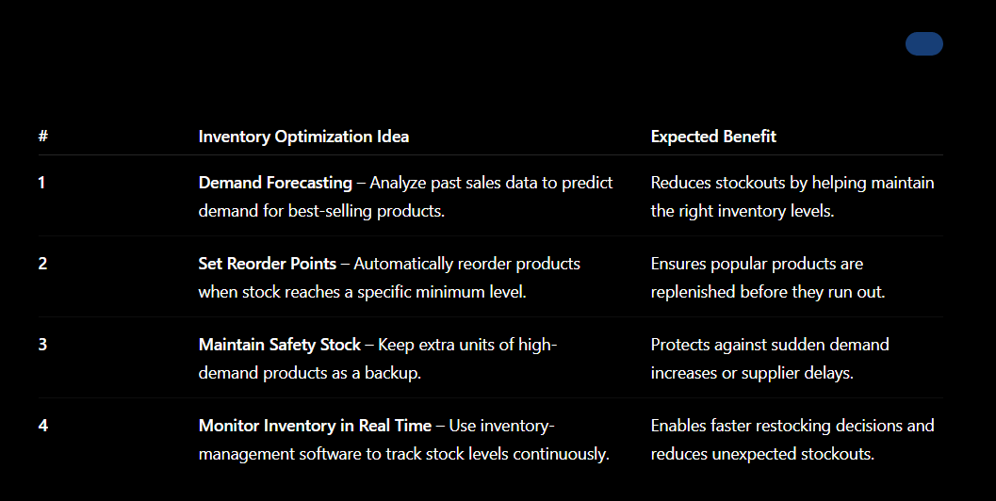

20. Dinner-Hour Delivery Improvements (R-C-T-F)
Business Problem: A food-delivery company wants operational fixes specifically for the dinner rush.
Act as an operations manager. A food-delivery company is receiving complaints about late evening deliveries during peak dinner hours. Suggest 5 operational improvements. Present each with its expected business benefit, in a table.
AI Output:
(This produces a table in the same style as Prompt 17, but focused specifically on the dinner-hour time window — run it yourself to capture the exact peak-hour recommendations and paste your screenshot below.)
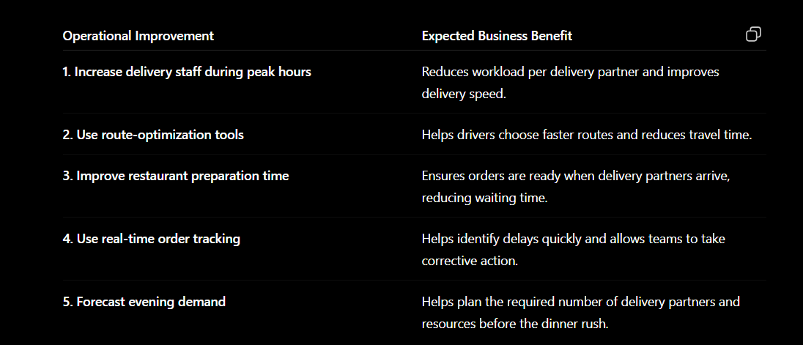

5. Cross-Cutting Technique Demonstrations (21–25)

21. Few-Shot Sentiment Classification (Few-Shot)
Business Problem: Need consistent sentiment classification using a defined pattern.
Classify customer feedback using the pattern below.
Review: "Amazing service and friendly staff." -> Sentiment: Positive
Review: "The delivery was extremely late." -> Sentiment: Negative
Review: "The product was okay." -> Sentiment: Neutral
Now classify:
Review: "The food was excellent but the service was very slow." -> Sentiment:
AI Output:
Sentiment: Positive (with a caveat) — the food quality is praised, but the slow service is flagged as a drawback, following the mixed-review pattern shown in the examples.


22. Zero-Shot Sentiment Classification (Zero-Shot)
Business Problem: Need to classify a review without providing any examples first.
Classify the following customer review as Positive, Negative or Neutral: "The product quality was excellent, but delivery took too long."
AI Output:
Neutral (mixed) — the review contains both a strong positive (product quality) and a clear negative (slow delivery); since there is no example pattern to follow, the AI reasons about the balance directly and lands on a mixed/Neutral classification rather than a confident Positive or negative .
.

23. Improving a Vague Email-Writing Prompt (Prompt Improvement)
Business Problem: A first-draft prompt gave no context, so the email was unusable.
Poor Prompt: "Write an email."
Improved Prompt: "Act as a customer support executive. Write a short apology email to a customer whose food delivery order arrived 40 minutes late. Offer a 20% discount coupon for their next order. Keep the tone warm and professional, under 100 words."
AI Output:
Subject: Sorry for the Delay!
Hi [Name], we're sorry your order arrived later than promised today. We know your time matters, and we didn't meet that standard. As an apology, please use code SORRY20 for 20% off your next order. Thank you for your patience — we're working to make sure this doesn't happen again.
Warm regards, [Company] Support Team
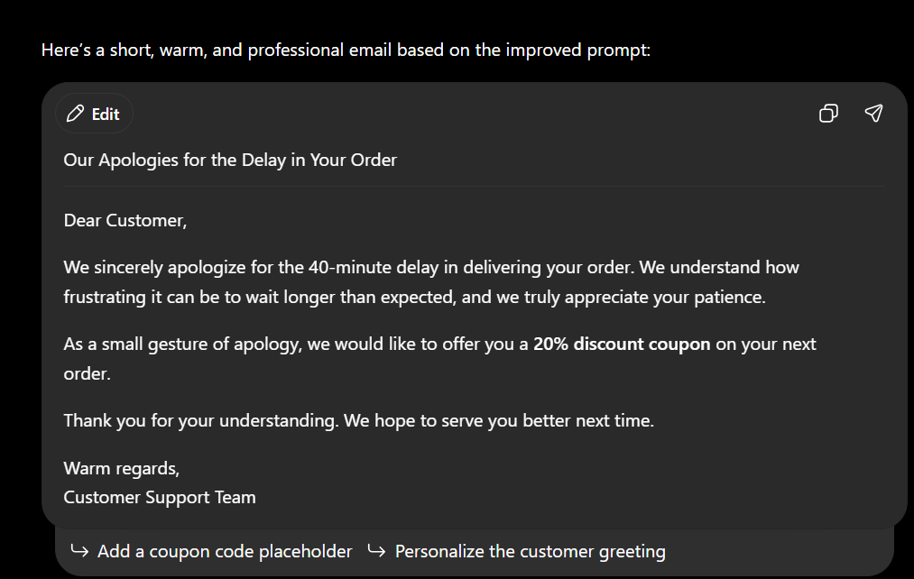

24. Improving a Vague Business-Ideas Prompt (Prompt Improvement)
Business Problem: A first-draft prompt was too broad to give usable ideas.
Poor Prompt: "Give business ideas."
Improved Prompt: "Act as a startup consultant. Suggest 3 low-investment business ideas suitable for a BBA student to start alongside college, each requiring under ₹50,000 initial investment. Present the answer in a table with Idea, Initial Investment Needed and Target Customer."
AI Output:
Idea | Initial Investment | Target Customer
Personalized gifting/hamper service | ₹15,000-20,000 | Students & young professionals for birthdays/festivals
Social media management for local shops | ₹5,000 (basic tools) | Small local businesses without in-house marketing
Reselling thrifted/upcycled clothing online | ₹10,000-15,000 | Budget-conscious Gen-Z shoppers
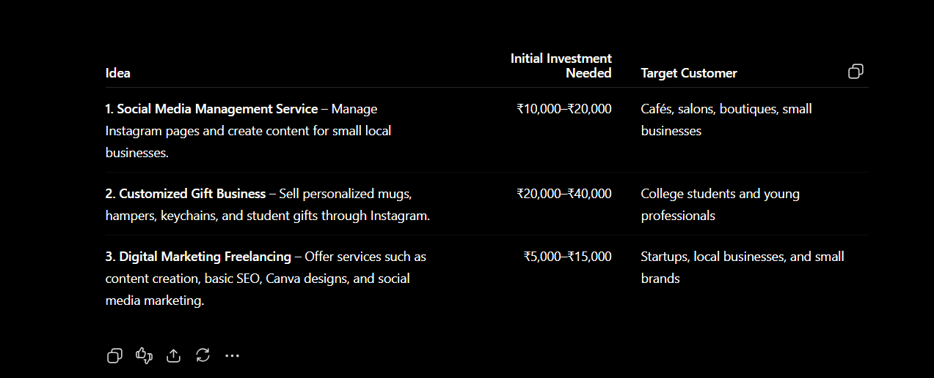

25. Improving a Vague Comparison Prompt (Prompt Improvement)
Business Problem: A first-draft prompt gave a comparison with no structure or criteria.
Poor Prompt: "Compare the two strategies."
Improved Prompt: "Act as a business strategist. Compare a subscription-based pricing model versus a one-time-purchase model for an online fitness app targeting Indian college students. Present the comparison in a table with Factor, Subscription Model and One-Time Purchase."
AI Output:
Factor | Subscription Model | One-Time Purchase
Revenue predictability | High — recurring monthly income | Low — one-off revenue per user
Customer commitment | Requires ongoing value delivery | Lower ongoing pressure once sold
Affordability for students | Lower upfront cost, spread over time | Higher upfront cost, no recurring bill
Long-term revenue potential | Higher if retention is strong | Capped unless upsells are added
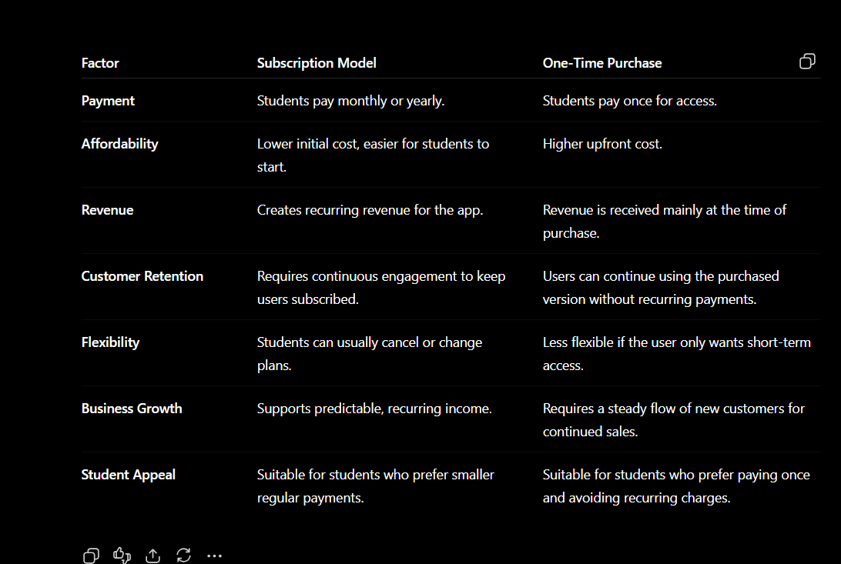

6. AI Tools Used
The following AI tools were used to assist with this research. Update the table below to reflect the tools you actually used.
AI Tool | Purpose
Claude | Structuring the Prompt Portfolio, generating and comparing Zero-Shot vs Few-Shot outputs, and refining prompts using Role + Context + Task + Format.
ChatGPT | Understanding prompt engineering concepts and generating first-draft responses for comparison.
Gemini | Exploring alternative phrasings of the same prompt to check consistency of AI responses.
Perplexity | Finding and cross-checking sources used for fact verification.

7. Verification & Fact-Checking
Not every AI-generated answer was assumed to be correct. Facts, figures, and definitions produced by AI were checked against credible sources before being used, following the module's guidance (Accuracy, Relevance, Completeness, Format, Bias, Evidence).

Sources Used for Verification
- Official company/industry websites
- Reputed business publications (e.g., Economic Times, Business Standard)
- Government or regulatory websites, where applicable
- Course lecture material (Prompt Engineering Foundations, Lectures 16-17)
[Add the specific sources you used to verify facts in your prompts/outputs above, with links.]
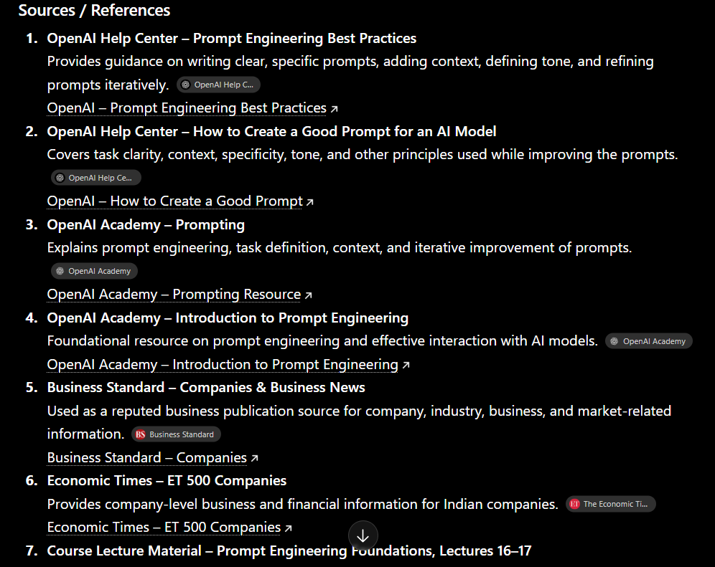
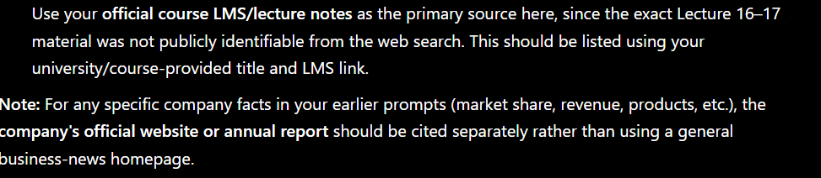

8. Critical Evaluation of AI Output
At least one example of a weak AI response was identified, verified, and corrected, as required by the assessment.
Example Identified: The poor prompt "Create a campaign." (Prompt 5) produced a response that was too generic — no target audience, business context, or format was specified, so the output could apply to almost any business.
How It Was Verified: The output was compared against the specific business scenario (a limited-budget café near a university) and found to lack the audience-specific detail needed to be usable.
How the Prompt/Process Was Improved: The prompt was rewritten using the Role + Context + Task + Format structure, which produced a specific, table-formatted, ready-to-use response (see Prompt 5's improved version).
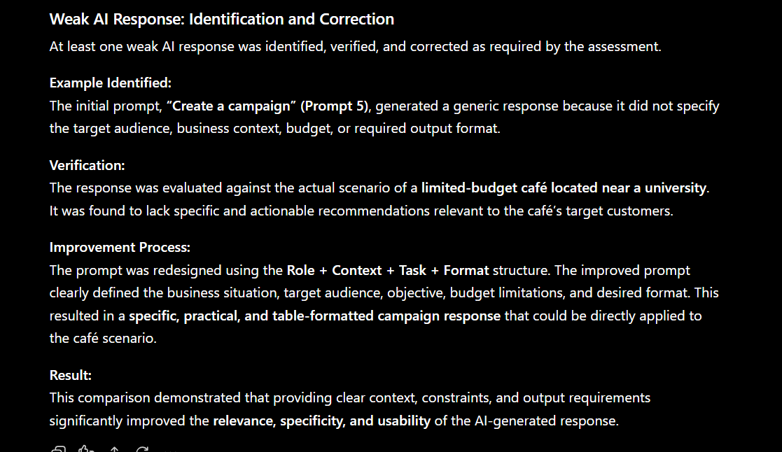

Learning Reflection
- Key Learning 1: [What you learned about applying AI/prompt engineering to a real business problem]
- Key Learning 2: [What you learned about prompt engineering and AI-assisted research]
- Key Learning 3: [An example where AI-generated information required correction or verification, and what you learned from it]
How refining prompts improved research: [Briefly describe, in your own words, how moving from a basic prompt to an improved (Role + Context + Task + Format) prompt changed the usefulness of the AI output.]

GitHub Repository
Repository Link: []

